DATA ANALYSIS AND DATA VISUALIZATION USING POWER

**ABSTRACT**

In today’s day-to-day life, visuals are our best friends when it comes to presenting data (spreadsheets, PowerPoint, lengthy word documents, etc., are no more). At the end of the day, you must be able to tell your story through data, which can understand easily by consumers. Generally, data visualization is meant to make easily understand the information, it’s just a graphical representation of data rather than representing the data in a complex spreadsheet, we can able to create an image that will illustrate the information easier. Data visualization helps you to compile the information into one place, which makes to easily remember the image than the text. The main feature of visualization helps to understand and remember it better. There are many different types involved in visualization namely: Graphs, Pie chart - tells the difference in values are wide use a pie chart they’re sample and everyone understands them, Bar charts, and Line charts – to see how one variable may be superior or inferior to another, Charts. Power BI is a Microsoft Business Intelligence application. This application helps you combine data from different sources and systems, then shape and present it in a way, so you understand what’s going on in the business. So basically, with this single app, you get to two crucial tasks namely one, identify dangers before they explode into massive headaches, and two, you get to discover the opportunities that will grow the business.

**Key Words:** Visualizations in Power BI, Area charts: Basic (Layered) and Stacked, Bar and column charts, Cards, Combo charts, Decomposition tree, Doughnut charts, Funnel charts, Data analytics (DA), Microsoft Power BI.

1. **INTRODUCTION:**

Power BI was first released in 2011, compared to Tableau which was released in 2005. Microsoft becoming a trendsetter in the business intelligence field. They’re implementing what the customer needs. Because they’re investing heavily in demand, if there’s demand this means that companies are implementing the Power BI solutions, which also means that they need people who know “How to implement it?”. Power BI mainly solves business problems namely: “Problem of sharing reports can be done easily, long implementations are done fast, eliminates decision paralysis (cause they’re more rigid in nature), Creates more beautiful reports.

In the early days, many people don’t know how to visualize data in large amounts. So, data visualization is the technique in graphical representing data visual elements like charts and graphs. It is one of the steps of the data science process, which states that after data has been collected, processed, and modeled, it must be visualized for outcomes to be made. It helps to spot trends, patterns, and outliers, for quick insights and to make better decisions. The project has been developed using various programming languages such as JAVA, JavaScript, and MySQL, enabling various functionalities in Front-End or Back-End.

* 1. **Problem Definition: -**

Data visualization as been a major task nowadays, data visualization enables one the locate, modify, and also enables one to analyze data which is a major thing in this society. For developing a business, one needs to have a keen knowledge of the business, which is the stats of the business. To improve the business this business data is much needed to be visualized, so that one check the ups and downs in their business. In the real-world visualization of data has become a big intricate task, and sometimes we might need to hire a skilled person for this kind of operation. Here comes the Power-BI into the gameplay to change the entire game manner, this enables us to visualize the data easily without any sorted skill required. This is a user-friendly application.

**2. EXISTING SYSTEM:**

At the beginning of this data visualization task, excel played a key role which has been developed a couple of years back, this enabled one to easily visualize the data in a different visual format. As it had a major advantage in this field it also comes with many disadvantages at the same time. The data that is to be visualized, should be in an unstructured format which is the only method that is accepted by excel. Excel does not enable one to create interlinked or inter-responsible visualizations. This cannot handle large amounts of data easily. Not only these mentioned factors but also, but many other factors make excel lack behind. All the mentioned factors encourage one to develop some advanced systems for this kind of task.

1. **PROPOSED SYSTEM:**

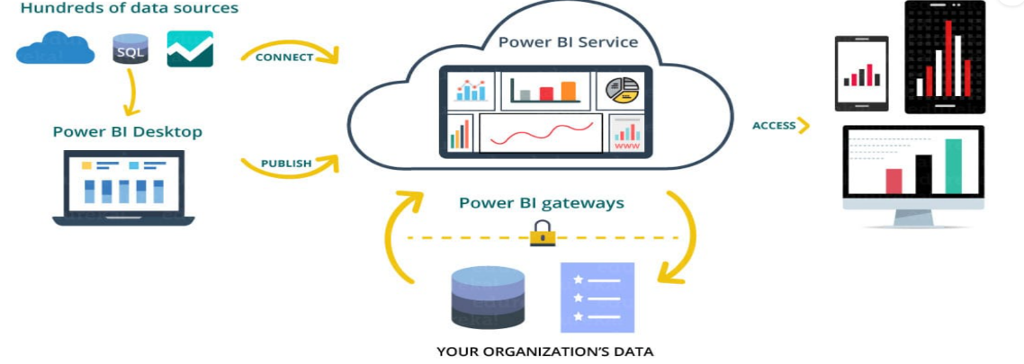

The main objective of our project is to develop an application where one can easily visualize data. Overcoming all the issues that are with the excel sheets in visualizing the data. This application makes the visualization task much easier and flawless for any different formats of the data, the data might be of any length and any size, and we also overcome the issue of interlinked visualizations in this project which was a major flaw of Microsoft excel. Many of the issues are been overcome in this project.

1. **METHODOLOGY:**

**POWER-BI (Business Intelligence):**

The Power-BI is a tool that enables one to easily visualize any type of data they needed, the data might be of a business company or else of any institution and many more. The major aim of the power-bi is to handle any type of data and visualize it in various types of formats like bar graphs, pie charts, maps, and many more. Power BI lets one quickly visualize and analyze the data without any specialized skills needed. One can easily get through the application as it is a pretty user-friendly application. This also has the ability to take the data as input from any kind of the sources like servers, data warehouses, webpages, excel sheets, and many more. It also comes with the real-time updating of the data i.e.; as the data gets updated in the backend it can be easily reflected in the application.

**ARCHITECTURE DIAGRAM:**

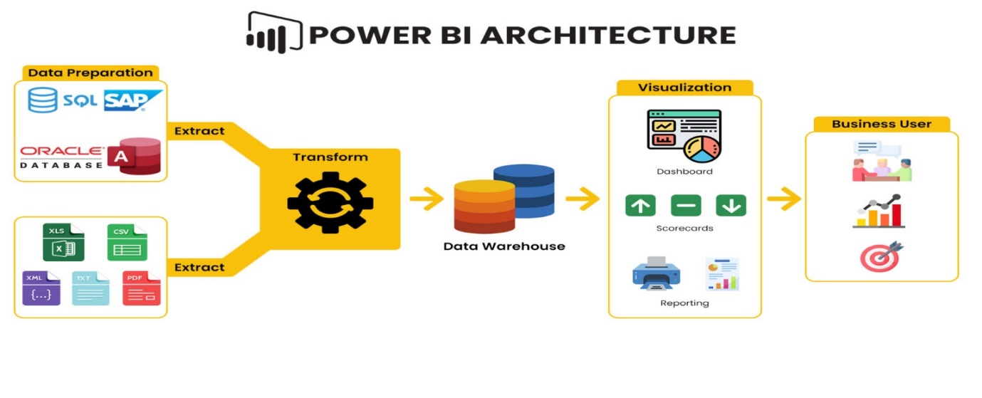

**IMPLEMENTATION:**

Data Analysis and Data Visualization Algorithm:

Step 1: Start.

Step 2: Entering the data in the website as input for the dataset.

Step 3: The filled data will be taken to the database with the help of JavaScript, where in our case database is the Google Forms.

Step 4: The data that is entered will be automatically stored in google forms in a tabular format in a sorted table.

Step 5: The stored data in the google forms will be uploaded lively.

Step 6: The data that is been inserted into the sheets will be published live and will be connected to our POWER-BI application

Step 7: The application which is connected to the database initially can retrieve the data from the sheets which is been uploaded in a live manner.

Step 8: The data which is retrieved on live from sheets will be processed.

Step 9: The processed data can be visualized in various formats.

Step 10: Using the various visualization techniques the data can be analyzed accurately.

Step 11: This accurate way of analysis helps us improve the business in various ways.

Step 12: Stop.

1. **RESULTS:**

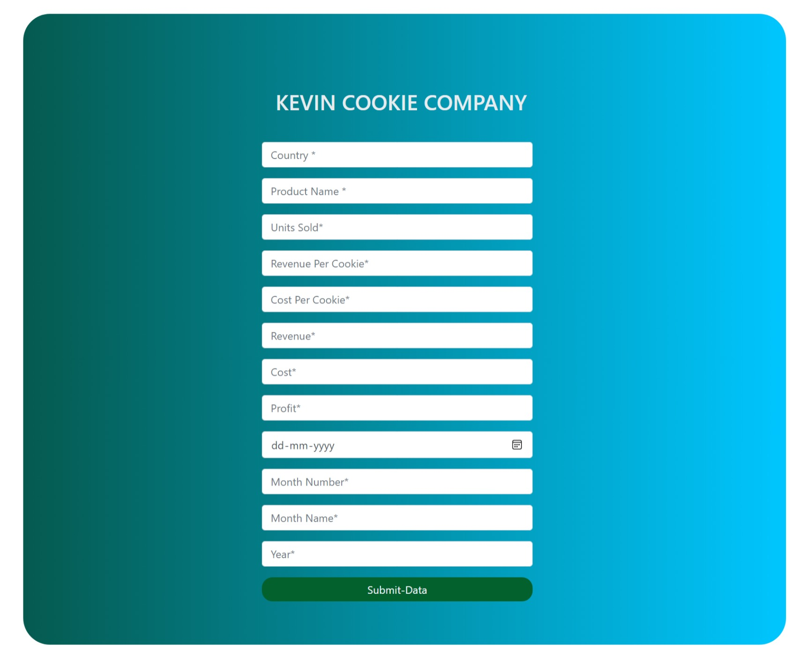

Fig -Webpage for taking input

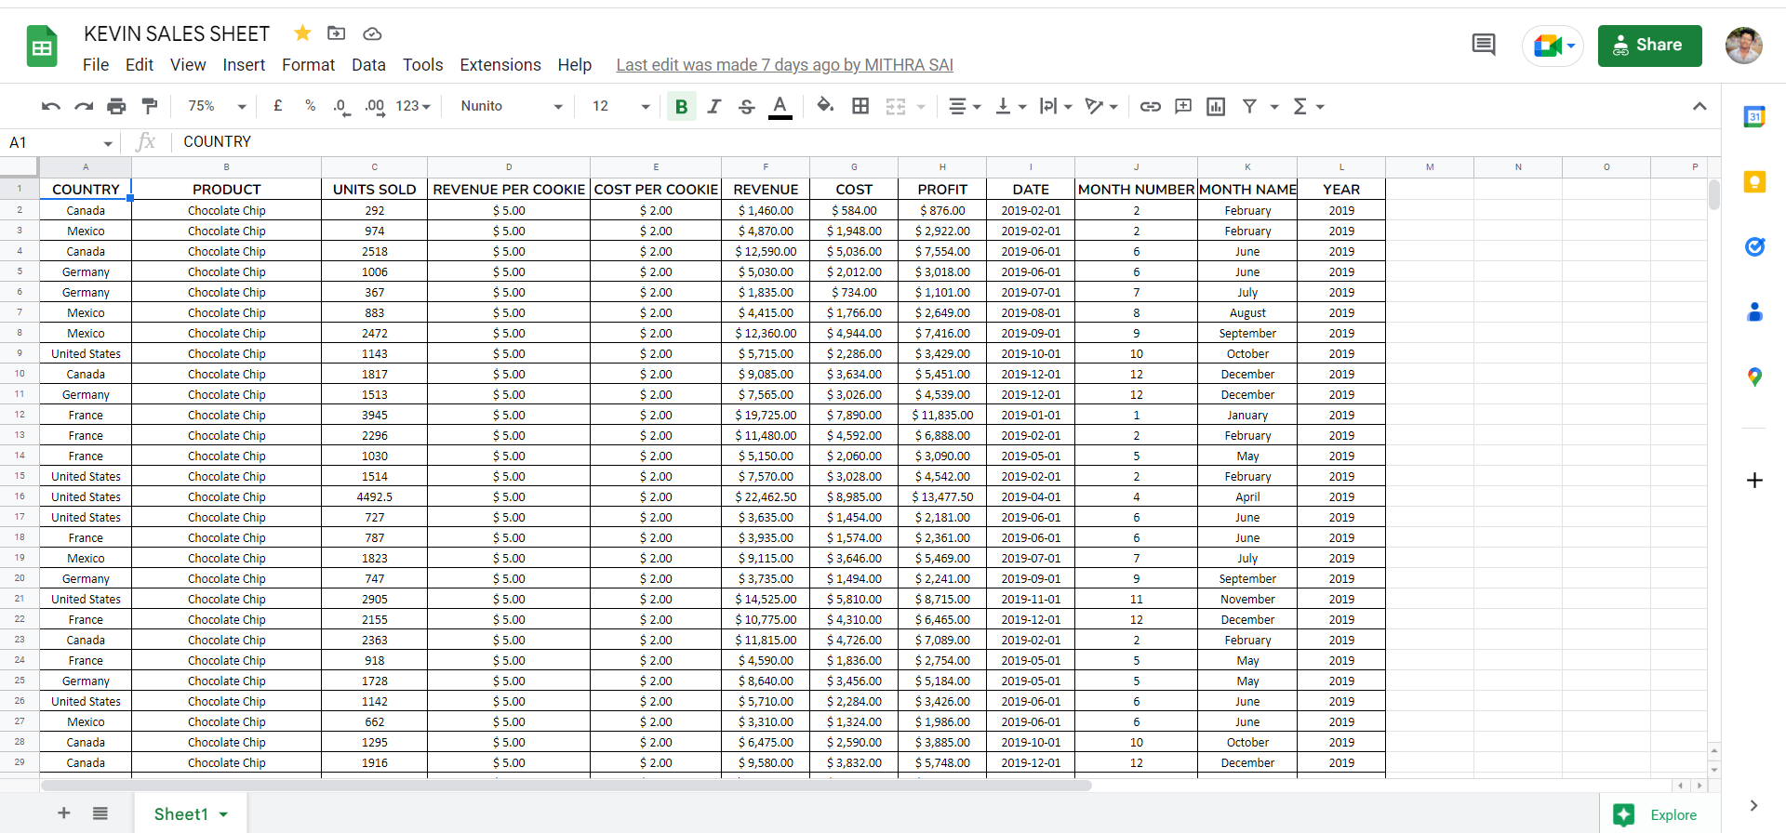

Fig - Data in the google forms

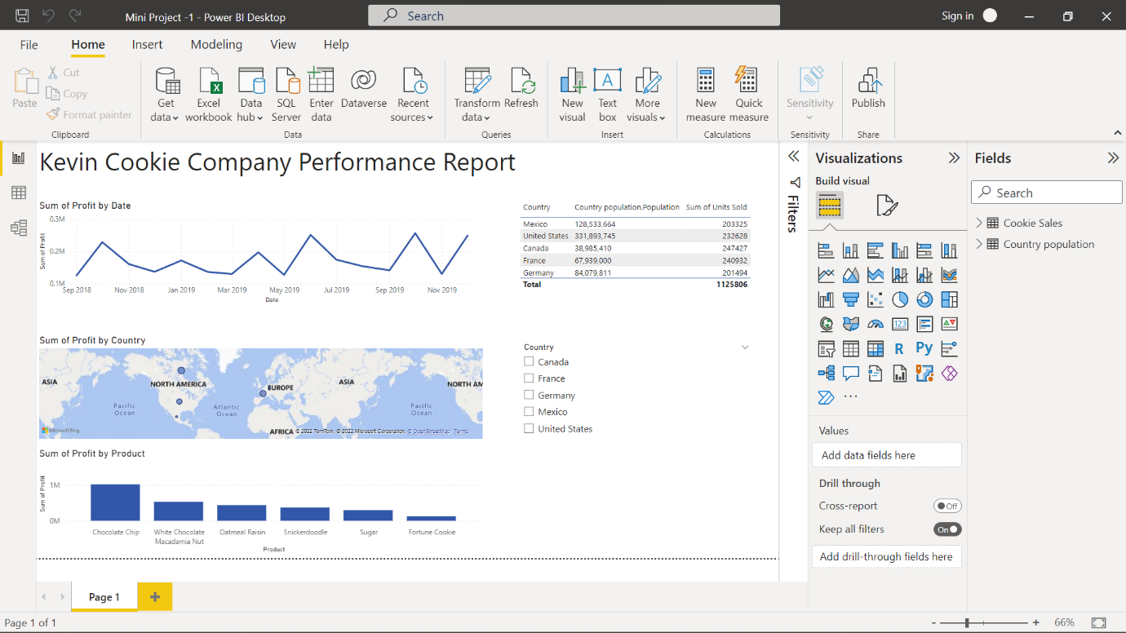

Fig – Dashboard

The above image shows the output of the program which is the dashboard for the given dataset which is Kevin’s cookie company. The above is the report of the data of Kevin’s cookie company which shows the different possible visualization methods using the data.

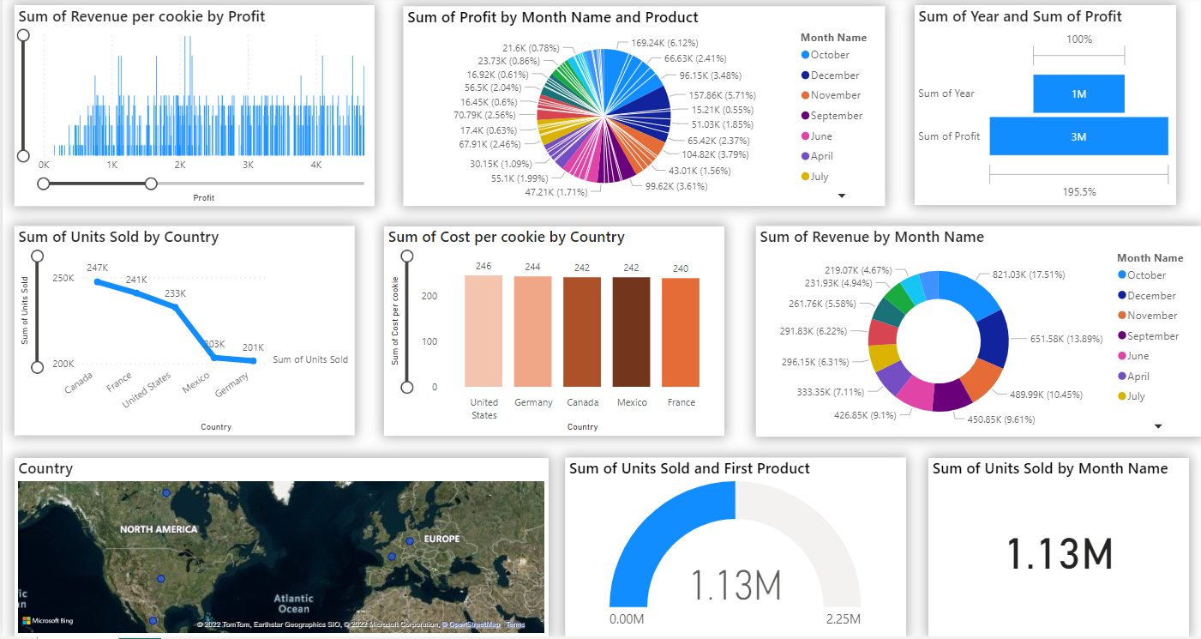

Fig 7.4 Advanced dashboard

The above image is the more visualized output or report for Kevin’s cookie company scales in the different countries for their different cookie products that have been sold in their perspective years.

**CONCLUSION:**

Our main objective is to enable a user to visualize the data in many formats which can help the user to analyze the data easily which majorly helps in the improvement of the business. In this one can feed their data to the application for processing using a web page that has been developed by us. The input data can be visualized using the Power-BI application in a real-time format.

**REFERENCES**

[1]. Microsoft, 2017, “Choose how to get started”, Accessed online at <https://powerbi.microsoft.com/en-us/get-started/>

[2]. Michael Hart, 2017, “Quick Insights with Power BI”, Accessed online at <https://powerbi.microsoft.com/en-us/documentation/powerbi-service-auto-insights/>

[3]. Microsoft Documentation, 2017, “What is Power BI”, Accessed online at <https://powerbi.microsoft.com/en-us/what-is-power-bi/>

[4]. Microsoft Documentation, 2017, “What is Power BI”, Accessed online at <https://powerbi.microsoft.com/en-us/what-is-power-bi/>

[5]. Microsoft, 2017, “Guided Learning”, Accessed online at <https://powerbi.microsoft.com/en-us/guided-learning/>